# Reexam 2024

Indholdsfortegnelse

Reexam 2024 1

Problem 1. Signal properties ( 20 % ) 2

Problem 2. Convolution ( 20 points ) 7

Problem 3. Fourier transform of rectangle. ( 15 points ) 10

Problem 4. Fourier & Laplace for differential equation solutions ( 20 points ) 12

Problem 5. Sampling theory 14

## Et billede, der indeholder tekst, diagram, linje/række, design Automatisk genereret beskrivelseProblem 1. Signal properties ( 20 % )

1. Create signal from manipulating a square signal

the signal wrongly at the start.  
   
Scaling it by a factor of 4.   
   
Active for   
, so it checks out.



Time shifting it:   
   
And I want it to activate at t = 0



*Ligningen løses for t_0 vha. WordMat.*



And for the second signal I will scale it to be twice g’s size.   
   
   
   
And it checks out.   
  
Now time shifting it:   
   
, given



*Ligningen løses for t_0 vha. WordMat.*



=========================================  
   
   
=========================================

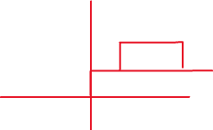

===================  
   
   
===================

1. Periodicity

For a period T.   
Let’s find out.   
So the first one is periodic, but causal.   
It is, cause it’s a pure sinusoidal signal and these are known to be periodic.

, t >0.   
That must mean that:



That means the signal is periodic if there exists an integer N0 where  
   
   
It won’t reach periodicity for the first sampled period.   
   
   
   
   
   
So the diskrete signal is periodic in

Is just a constant so it isn’t periodic.

===============   
 √,   
 √,   
 %  
===============

1. Et billede, der indeholder tekst, Font/skrifttype

   Automatisk genereret beskrivelseSystem characteristics of

Memoryless:

The system is memoryless, if it only depends at times at t = 0.   
This isn’t true, as it’s depended on time delayed by 1.

Causal:   
The system is causal, if it takes in no future values into the system… if it doesn’t try to predict what’s going to happen.  
Our system is only depended on past values, and does therefore not try to predict any future.   
Our system is causal.

Time invariant:

Time invariancy is when a change in the input equals the same change at the output.   
I can immediately see that this system isn’t as time at the output acts as a scalar to the input. And thus a change at the input won’t equal a change at the output.

Linearity:

Does a scalar at the input translate to a scalar at the output? Let’s find out.

and it is linear.

And so it is linear.

======================  
Memoryless %  
Causal √  
Time invariant √  
Linear √  
======================

## Et billede, der indeholder tekst, Font/skrifttype, algebra Automatisk genereret beskrivelseProblem 2. Convolution ( 20 points )

What’s ?

Using the convolution integral

1. Sketch x and h.



1. Compute using the convolution integral.

Nonzero for   
   
   
   
   
   
============  
   
============

1. Sketch it.
2. Et billede, der indeholder tekst, Font/skrifttype, hvid, kvittering

   Automatisk genereret beskrivelseConvolution sum

1. Et billede, der indeholder skærmbillede, tekst, diagram, linje/række

   Automatisk genereret beskrivelseSketch the signals
2. Et billede, der indeholder tekst, Font/skrifttype, hvid, linje/række

   Automatisk genereret beskrivelseCompute using the convolution sum

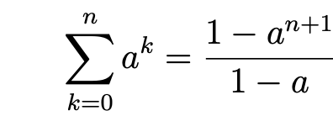Nonzero for

=====================  
   
=====================

1. Sketch y[n]

## Et billede, der indeholder tekst, skærmbillede, Font/skrifttype, algebra Automatisk genereret beskrivelseProblem 3. Fourier transform of rectangle. ( 15 points )

1. Sketch the signal

‘’’

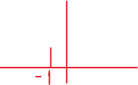

1. Et billede, der indeholder tekst, Font/skrifttype, linje/række, hvid

   Automatisk genereret beskrivelseCompute the fourier transform using the analysis equation.

===============  
   
===============  
If we were to rectangle by t = 1 to the left, then we could write this as a sinc function.

1. Et billede, der indeholder tekst, Font/skrifttype, skærmbillede, linje/række

   Automatisk genereret beskrivelseExpress in terms of magnitude

result  
Next step planned:

## Et billede, der indeholder tekst, Font/skrifttype, skærmbillede, algebra Automatisk genereret beskrivelseProblem 4. Fourier & Laplace for differential equation solutions ( 20 points )

1. *Fourier solution*
2. Calculate the frequency response.

Using fourier property:   
   
And the linearity property, as this is a LTI system.

==================  
   
==================

1. Sketch its bode plot.

It seems to act as a high pass filter.

1. Laplace solutions
2. Determine

Using the laplace differentiation & the laplace linearity property.

===============  
   
===============

1. Determine the poles and zeros of and indicate their location on an s plane.

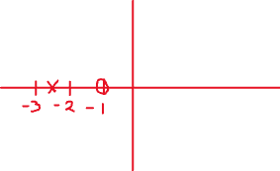

============   
   
   
============

## Et billede, der indeholder tekst, Font/skrifttype, algebra Automatisk genereret beskrivelseProblem 5. Sampling theory

1. ( 4 points ).

To sample a signal without losing information we must make sure both sides of the frequency spectrum is withing our sampling range.

Where is the highest frequency component.   
   
   
This is the minimum sampling frequency, for no information losses.  
  
   
   
   
   
So as the min is set, the maximum has then also been set.   
==================   
*Max   
Min*==================

1. ( 16 points )
2. Sketch

It’s a pure tone, it’s frequency can be described as two frequencies, symmetric around the axis.  
   
   
Is just a frequency spectrum that repeats for every

‘’’

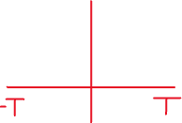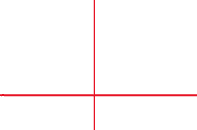

The content of P’s spectrum has the exponential becoming narrower and narrower, the further away from the axis it gets, due to the period becoming smaller and smaller.